Chicago Crime Incident Data Analysis for Tourism Support

Dec 13, 2024
Team 7

Group Name and Members:
1. Dean Qiu
2. Hyunji Amy Kim
3. Savita Vinayaga Moorthi
4. Vicki Yuan
5. Yuchen Wang

1 Introduction

1.1 Executive Summary
As one of the major cities in the United States, Chicago is often perceived as having high crime rates, particularly for violent crimes. This perception impacts tourism, discouraging visitors and affecting local businesses. However, concerns about crime are often based on broad statistics that fail to fully capture localized safety insights. Crime rates are influenced by factors such as population density, economic conditions, and neighborhood variations. This project analyzes Chicago crime incident data to provide accurate and localized safety insights. By identifying safer areas, optimal visiting times, and the nature of common incidents, the findings will empower stakeholders to make data-driven decisions that enhance safety and promote tourism.

1.2 Project Objectives
This project aims to deliver actionable safety insights by analyzing Chicago’s crime data. Through identifying high-crime areas and optimal visiting times, the analysis seeks to enhance tourist safety and confidence. Interactive dashboards will provide stakeholders with clear and accessible tools to monitor crime trends, and these will enable them to improve visitor experiences and develop targeted safety strategies.

2 Business Case
Chicago’s reputation for high crime rates impacts tourism by deterring potential visitors and affecting local businesses. The project seeks to address these concerns by offering actionable, data-driven insights into neighborhood safety, visitor guidance, and crime trends. These insights will support stakeholders–such as the Chicago Tourism Board, local businesses, and city planners–to highlight safer neighborhoods, recommend optimal visiting times, and improve security practices in tourist-centric areas. Ultimately, the project seeks to dispel misconceptions, enhance visitor confidence, and promote sustainable tourism by creating a safer and more welcoming image of Chicago.

2.1 Project Rationale
Chicago’s reputation for high crime rates can deter tourists, reducing economic growth and negatively affecting local businesses. Accurate and localized crime insights can help correct these misconceptions and highlight safer areas and times for visiting. These insights will not only support tourism growth but also improve visitor satisfaction and safety.

2.2 Key Stakeholder Concerns
Key stakeholders, including tourism boards, local businesses, and city planners, are interested actionable insights to address the following concerns:

- Identifying safe neighborhoods for tourists (Addressed through Geographic Analysis).
- Understanding common crime types near popular tourist areas (Addressed through Crime Type Analysis).
- Pinpointing times with lower crime rates to enhance visitor safety (Addressed through Temporal Analysis).

Answering these questions will enable stakeholders to improve visitor safety, promote sustainable tourism, and enhance Chicago’s image as a safe and welcoming destination.

2.3 Proposed Analyses and Reports
To address stakeholder needs, we propose the following analyses and reports:

- Geographic Analysis: Mapping crime incidents by neighborhood will reveal safer areas, helping stakeholders prioritize safety investments and guide tourists toward low-crime zones.
- Temporal Analysis: Identifying times of day, days of the week, and month with lower crime rates will reveal optimal times for visiting.
- Crime Type Analysis: Categorizing crime types in tourist-centric areas will help develop targeted safety initiatives and visitor awareness campaigns to reduce risks.

3 Data Source
This project utilizes two publicly available datasets from the Chicago Data Portal:

- Chicago Crime Incident Data
  - Source: https://data.cityofchicago.org/Public-Safety/Crimes-One-year-prior-to-present/x2n5-8w5q/about_data
  - This dataset contains 258,062 records and 31 features, of reported crime incidents within Chicago over the past year. This data is sourced from the Chicago Police Department’s CLEAR (Citizen Law Enforcement Analysis and Reporting) system. Key attributes include approximate block-level locations, dates, arrest records, and crime types, which provide the foundation for analyzing unsafe areas and predicting crime trends based on historical patterns.

- Community Area Boundaries Data
  - Source: https://data.cityofchicago.org/Facilities-Geographic-Boundaries/Boundaries-Community-Areas-current-/cauq-8yn6
  - This dataset provides geographic boundary information for Chicago’s community areas, which is essential for mapping and contextualizing crime data within specific neighborhoods.

The combination of these datasets will allow comprehensive analysis by linking crime incidents with their respective community areas, to identify unsafe areas and trends effectively. Figure 1 summarizes the key attributes in the crime incident dataset.

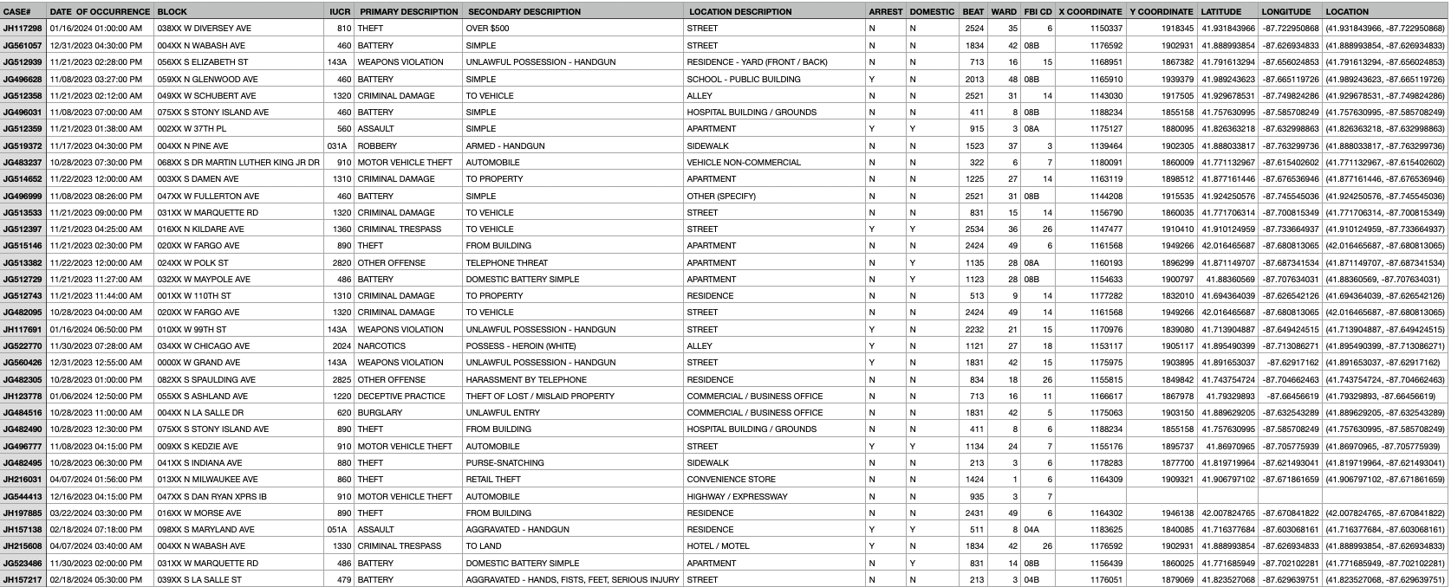
Figure 1. Overview of Chicago Crime Incident Data

4 Data Models

4.1 Conceptual, Logical, and Physical Data Models
This project's data model supports the analysis of Chicago crime incidents, prioritizing scalability, data integrity, and performance. The data is normalized into 3rd Normal Form (3NF) to minimize redundancy and ensure consistent data relationships. The primary entities include:

- Cases: Represents individual crime incidents, including attributes such as the date, time, arrest status, and IUCR classification (e.g., '0110' for homicide). The table’s primary key is case_no, and foreign keys include iucr (linking to Incident Type) and location_id (linking to Case Location).
- Incident Type: Contains standardized classifications of crimes, with primary and secondary descriptions (e.g., "Theft: Over $500"). The table is linked to cases through the IUCR code.
- Case Location: Stores geographic details for each crime, such as block, community, latitude, and longitude. The primary key is location_id, and it is linked to Community Description via a foreign key (community_id).
- Location Description: Adds contextual information about the crime’s specific location (e.g., street, alley). Primary key is loc_des_id, linked to Case Location.
- Community Description: Links crime cases to community areas with attributes like community_name (e.g., "Hyde Park") and geographic metadata (e.g., shape area and length). The primary key is community_id.

Table 1 illustrates primary and foreign key relationships, while Table 2 maps the hierarchical 1:N relationships among the tables. Figure 2 presents the Entity Relationship (ER) Diagram of the normalized structure.

Table name | Key | Attributes
cases | PK | case_no
cases | FK | iucr, location_id
incident_type | PK | iucr
case_location | PK | location_id
case_location | FK | loc_des_id, community_id
location_description | PK | loc_des_id
community_description | PK | community_id
Table 1. Primary and Foreign Key Relationships Across the Normalized Tables

Relationships
case_location and cases have 1:N relationships
incident_type and cases have 1:N relationships
location_description and case_location have 1:N relationships
community_description and case_location have 1:N relationships
Table 2. Mapping of One-to-Many Relationships Among the Tables

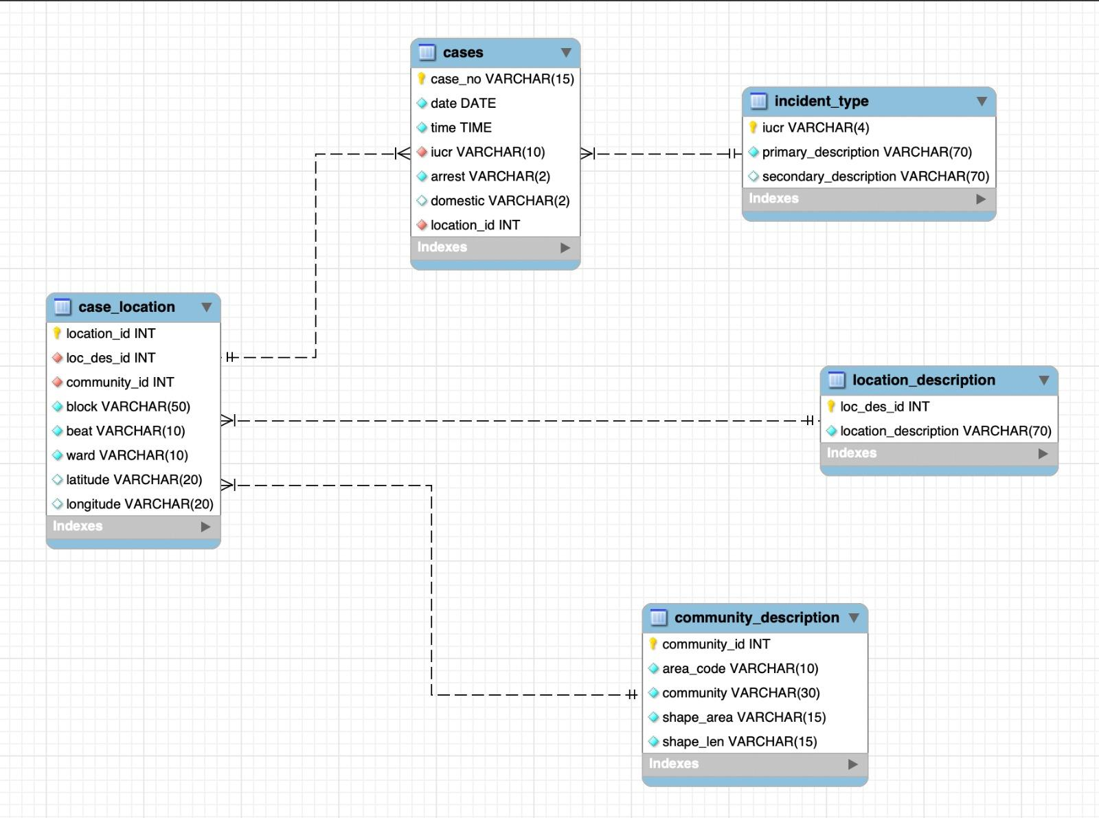
Figure 2. Entity Relationship (ER) Diagram

4.2 Relational Model
The data is organized in a relational model, and we decided to use the relational model rather than dimensional model based on the following reasons:

- Data Structure and Volume: Our data can be divided into different entity types (ex: community, location, case, etc) and they are interrelated with each other. It’s more helpful to remain highly consistent and normalized. Therefore, a relational model is appropriate.
- System Goals and Priorities: Although right now we only focus on 12 months of data, if in the future we need to update the database with new data, we will need the ability to handle numerous small read/write operations efficiently. In this sense, we chose the relational database.

5 Dataset Profiling & Data Cleaning

5.1 Missing Values
Column names are standardized to remove leading/trailing spaces and improve readability (e.g., 'DATE OF OCCURRENCE' is renamed to 'Date of Occurrence').

Missing values are addressed as follows:
- For LOCATION DESCRIPTION, missing entries are replaced with 'unknown' to retain records for analysis without introducing biases.
- For geographic coordinates (LATITUDE and LONGITUDE), missing values are imputed with 'unknown' to avoid discarding rows while ensuring data integrity.

Text fields are stripped of extra spaces and converted to a consistent case format for uniformity across the dataset.

Figure 3 illustrates the missing values included in the dataset.

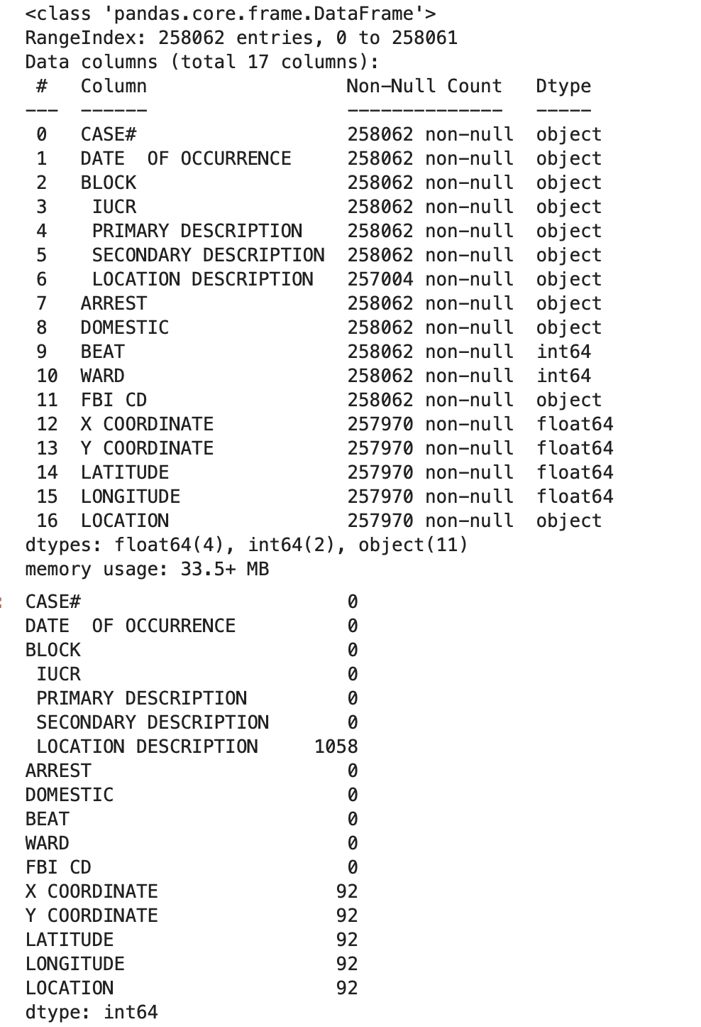
Figure 3. Missing Values

5.2 Data Transformation

We performed temporal transformation to support time-based analysis:
- DATE OF OCCURRENCE is converted to a proper datetime format.
- Derived columns are created to extract granular date components, such as year, month, day, day of week, and hour. For example, '2023-10-15 14:35' is transformed into Year: 2023, Month: October, Day: 15, Hour: 14.

Boolean columns (ARREST and DOMESTIC) are standardized to a consistent True/False format to enhance clarity and compatibility with analysis tools.

5.3 Data Deduplication
A total of 9 duplicate rows and 31 duplicate case numbers were identified and removed. Duplicates were identified by checking for identical values across all columns or repeated case_no entries, which could skew analysis if left unaddressed.

5.4 Categorical Variables
Categorical values such as crime descriptions (PRIMARY DESCRIPTION, SECONDARY DESCRIPTION) are normalized to ensure consistency. For instance, descriptions like 'THEFT' and 'Theft' are standardized to 'Theft'.

Numeric fields like WARD are mapped to descriptive names (e.g., 'Ward 1' to 'Near North Side') where mappings are available.

6. Methodology & Tools Used
This section outlines the tools and methodologies employed to perform the analysis, including database management, data processing, and data visualization. Each tool was chosen for its strengths in handling specific aspects of the project.

6.1 Database Management and Storage

Tool: MySQL
We selected MySQL, a widely-used relational database management system (RDBMS), for its reliability, scalability, and compatibility with structured data. MySQL served as the primary storage solution for the normalized data model, and supported retrieval of crime-related data. The following tasks were performed using MySQL:

- Normalization: We normalized the data into 3rd Normal Form (3NF) using MySQL.
- Query Optimization
- Integration: The database seamlessly integrated with Python for data analysis and Tableau for visualization, which enabled smooth workflows across all stages of the project.

In addition, MySQL can accommodate future data expansions, including additional years of crime data and new attributes like geographic and categorical information.

6.2 Data Processing and Analysis

Tool: SQL and Python
Data processing and analysis are carried out using a combination of SQL and Python, for a streamlined and efficient workflow.

- SQL:
SQL was utilized for querying and pre-processing the data stored in MySQL. Key tasks included:
  - Filtering and cleaning raw data by removing duplicate records and handling missing values.
  - Aggregating and summarizing crime data across temporal, geographic, and categorical dimensions to support our exploratory data analysis.
  - Data extraction, querying, and integrating normalized tables.
- Python:
Python is employed for more advanced data manipulation, automation, and analysis tasks. Key applications included:
  - Exploratory Data Analysis (EDA): Libraries like Pandas and NumPy were used to explore crime trends and identify outliers.
  - Automation: Automated data import into SQL using SQLAlchemy
  - Data Cleaning: Addressed inconsistencies, filled missing values with advanced imputation techniques, and standardized categorical and text fields for consistency.
  - Derived Features: Extracted temporal features like year, month, day of the week, and hour from the date column for temporal trend analysis.

6.3 Data Visualization

Tool: Tableau
Tableau was used to create intuitive and interactive graphs and dashboards. Tableau was critical for transforming complex datasets into actionable insights for stakeholders. Key visualizations included:

- Crime Heatmaps: Identifying hotspots and trends by highlighting high-crime areas across Chicago’s neighborhoods.
- Temporal Trends: Visualizing crime patterns over time, such as identifying safer hours, days, or months for visitors.
- Crime Category Breakdown: Displaying the distribution of crime types in tourist and non-tourist areas.
- Geographical Maps: Visualizing crime rate by community boundaries.

These interactive dashboards were mainly created to effectively communicate our findings to stakeholders.

6.4 Automation

Tool: Python, Tableau
Automation played a crucial role in ensuring a seamless end-to-end workflow:

- Data Import: Automated using Python’s SQLAlchemy library to load raw data into MySQL.
- Data Transformation: Python scripts automated the extraction of temporal features and the cleaning of categorical fields.
- Dashboard Updates: Tableau dashboards were dynamically linked to MySQL, ensuring real-time updates with minimal manual intervention.

7 Results & Insights

7.1 Result Visualization

7.1.1 Neighborhood Crime Trends in Chicago
Analysis reveals significant differences in crime distribution between tourist and non-tourist areas. This can be used for tourism strategies and safety planning (Figure 4):

- Nighttime Safety: Non-tourist areas experience a significant spike in crimes during nighttime hours, whereas tourist areas show relatively low crime rates. This makes tourist neighborhoods safer for evening and nighttime activities.
- Consistent Safety Advantage: Across all time periods—morning, afternoon, evening, and night—tourist areas report considerably fewer crimes than non-tourist areas. This is a positive indicator for tourism marketing.
- Daytime Exploration: Tourist areas exhibit particularly low crime counts during the morning and afternoon, with crime rates less than half of those observed in non-tourist areas. This highlights the suitability of tourist areas for daytime exploration.

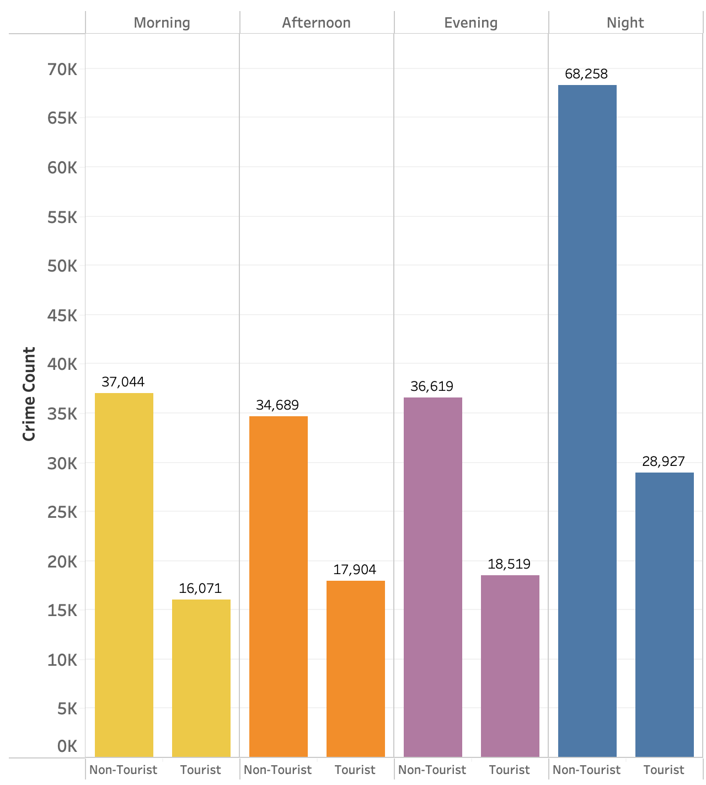
Figure 4. Crime Distribution Across Tourist and Non-Tourist Neighborhoods

Figure 5 and 6 provide a detailed comparison of crime levels in tourist and non-tourist neighborhoods:

- Tourist Neighborhoods:
  - Near North Side, the Loop, and South Shore, show higher crime concentrations. Those areas require enhanced safety measures.
  - Safe neighborhoods, such as Bridgeport, Kenwood, and Hyde Park, have significantly lower crime counts, making them ideal for promoting as secure destinations for tourists.
- Non-Tourist Neighborhoods:
  - Unsafe neighborhoods like Austin, Humboldt Park, and Englewood exhibit the highest crime rates among non-tourist areas. These areas may benefit from targeted interventions to address safety concerns.
  - Safe neighborhoods such as Edison Park, Mount Greenwood, and Forest Glen report minimal crime levels.

By leveraging these insights, city planners, businesses, and tourism boards can create targeted approaches to enhance safety and promote tourism.
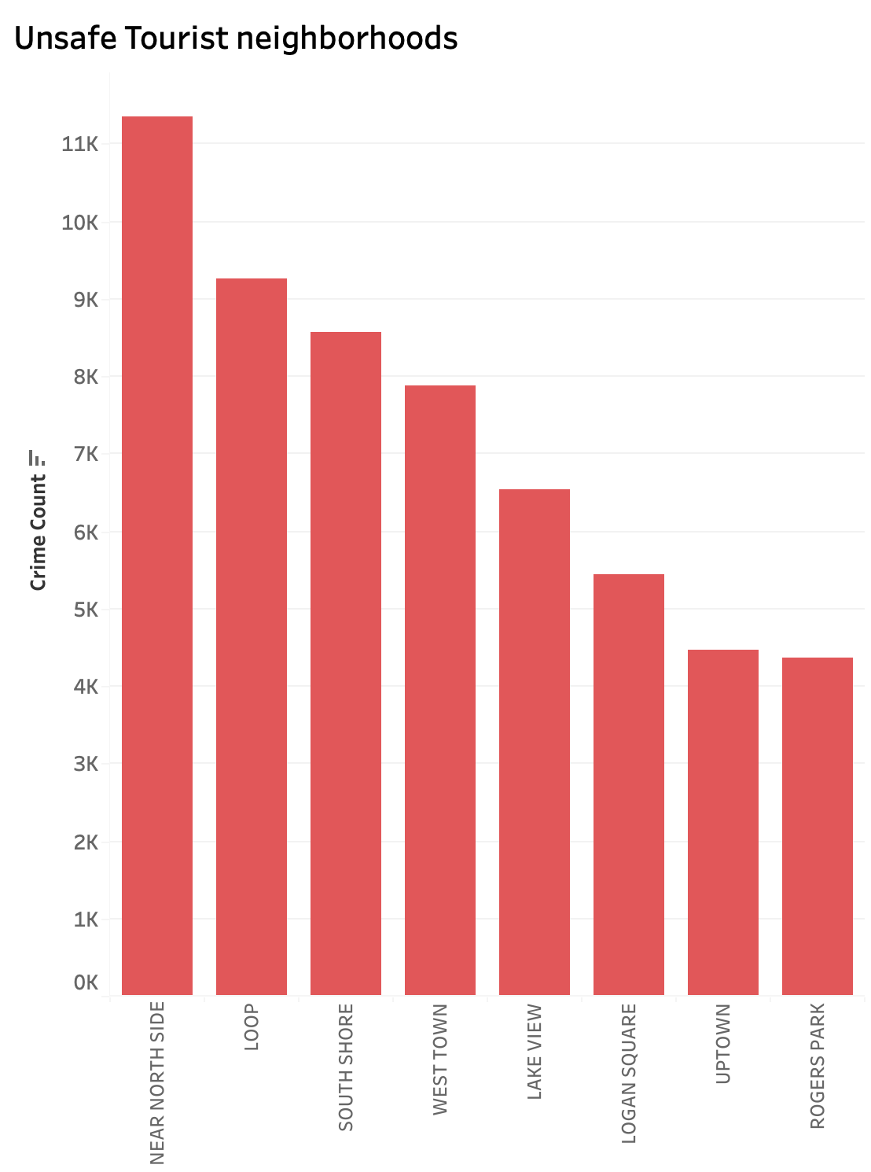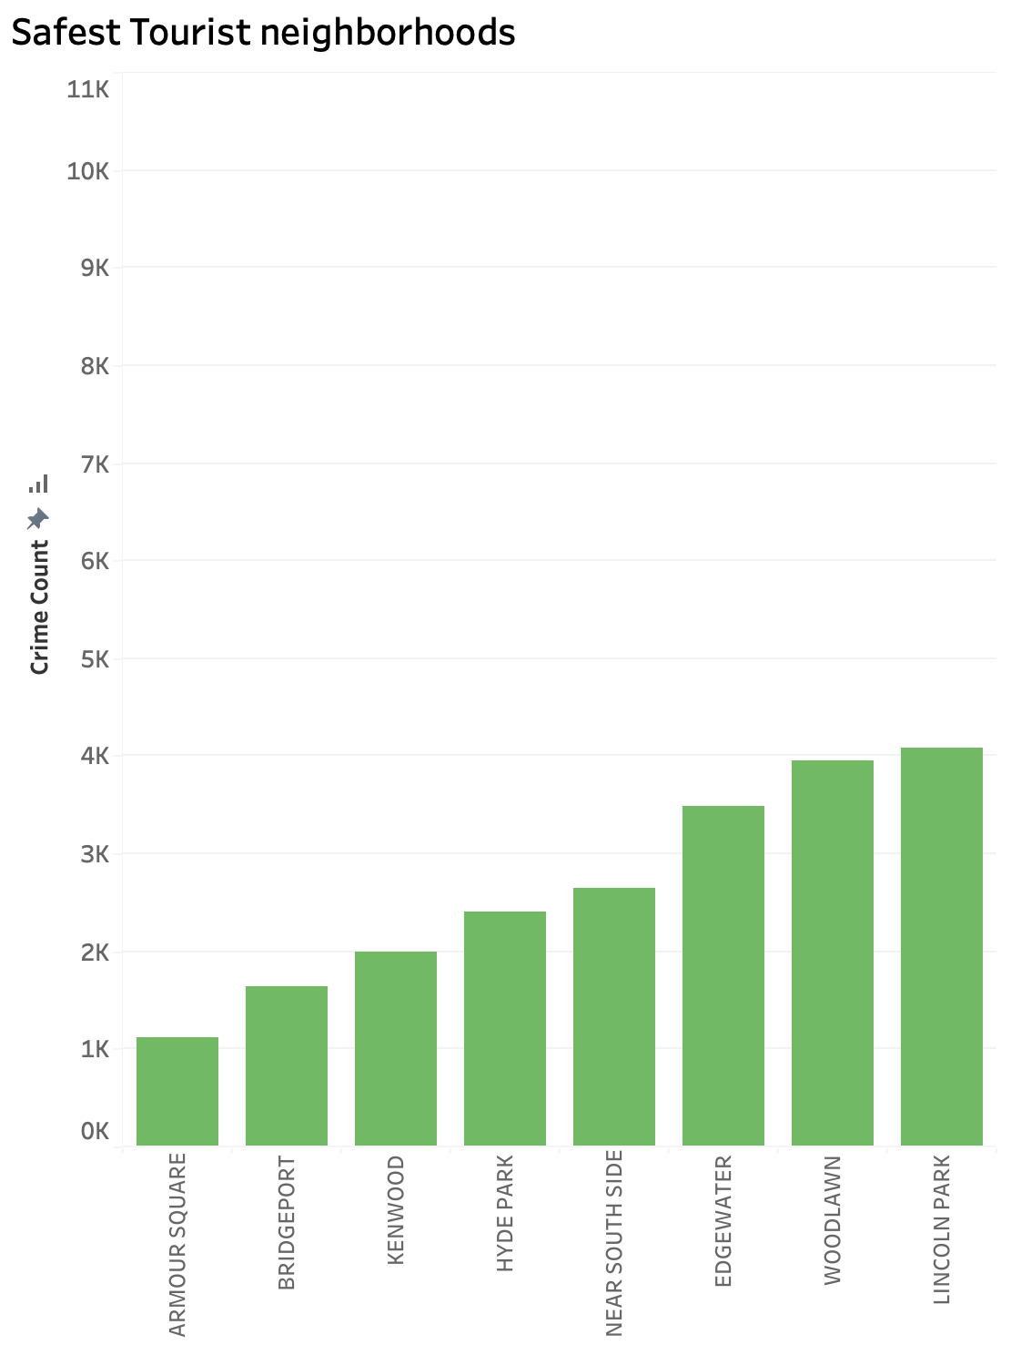
Figure 5. Unsafe vs Safe Tourist Neighborhoods

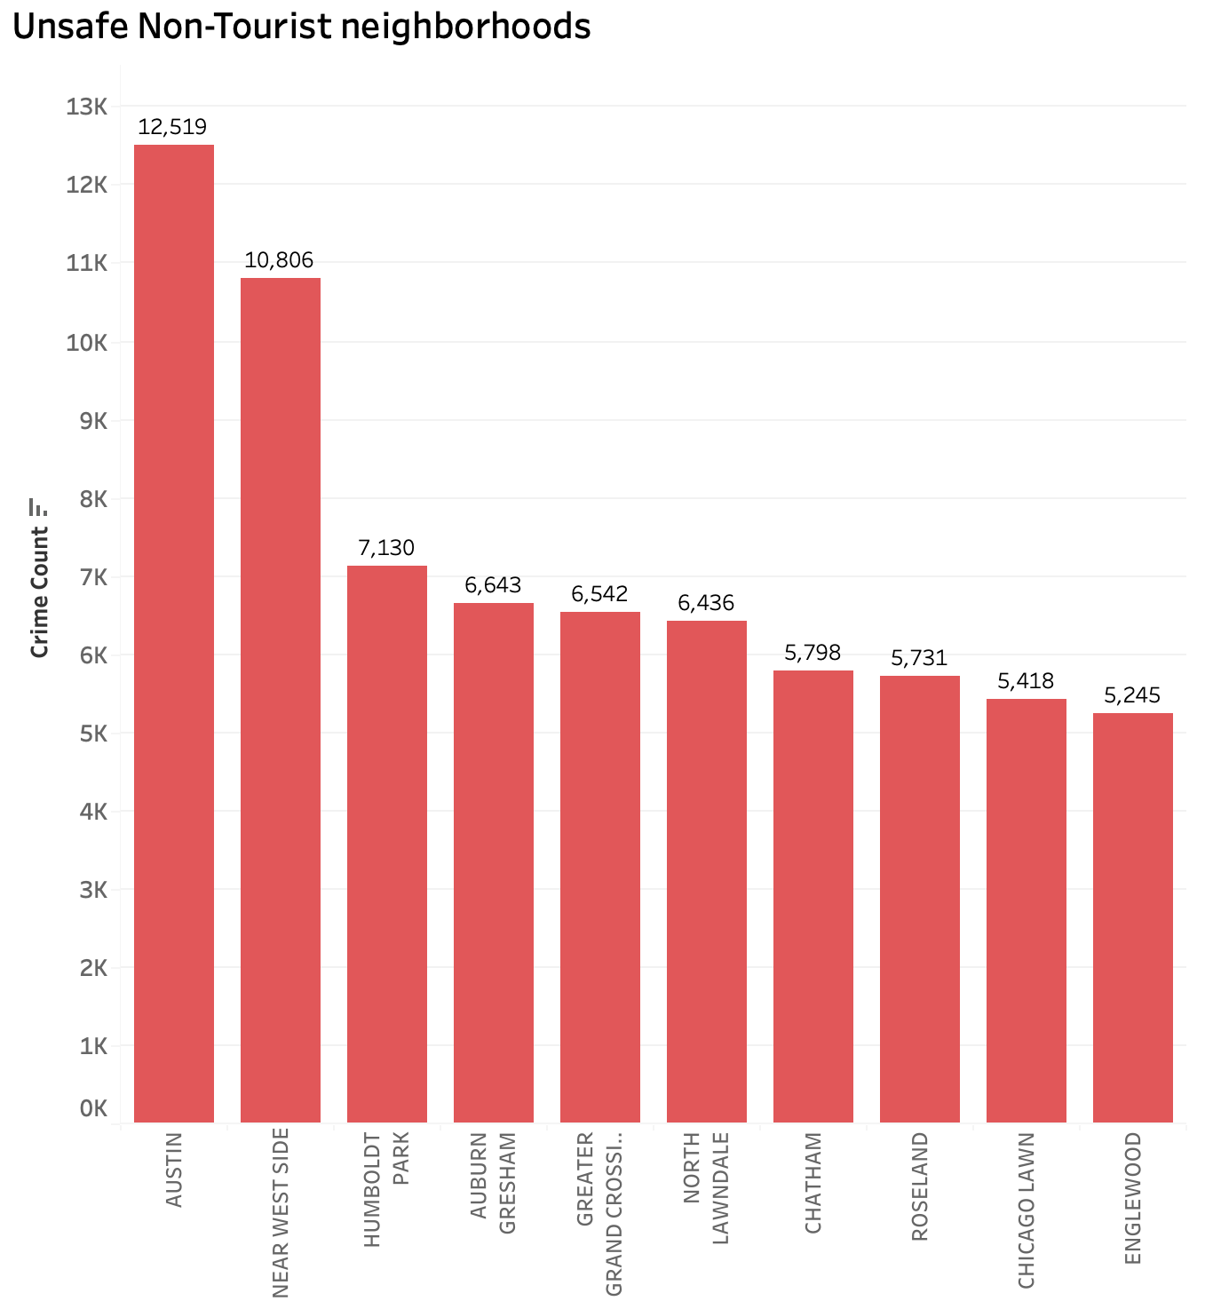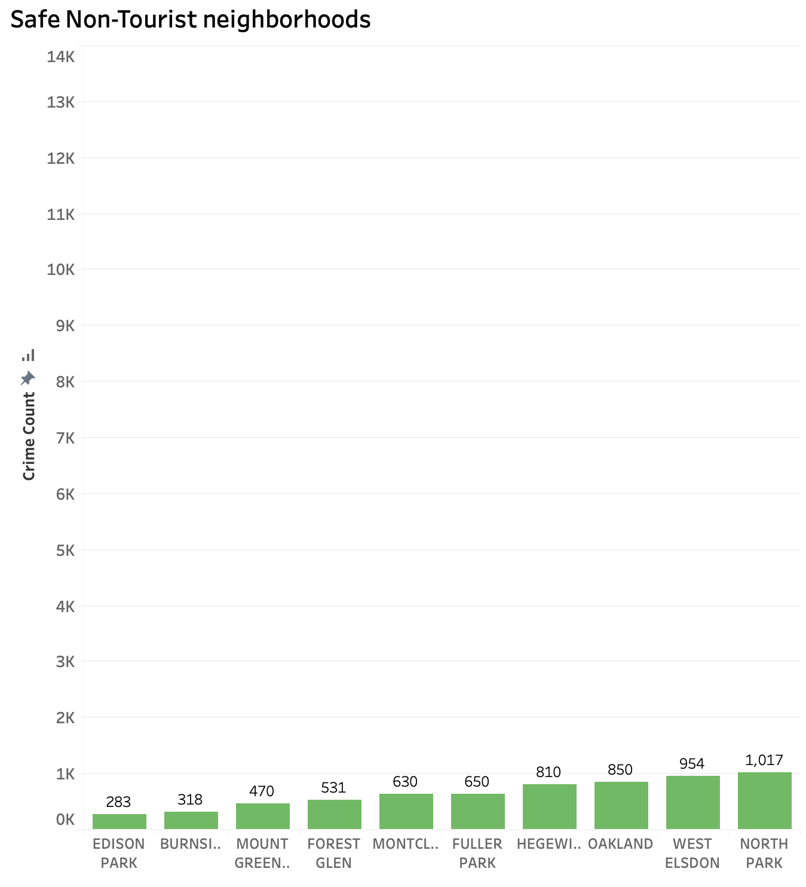
Figure 6. Unsafe vs Safe Non-Tourist Neighborhoods

7.1.2 Time Analysis of Crime Rates
The time analysis of crime rates provides key insights into when criminal activity peaks and declines across Chicago, which could offer valuable information for improving public safety strategies and guiding tourism recommendations.

Key observations in the time analysis include (Figure 7):
- High-Risk Hours: Late evenings and nighttime hours (8 PM–12 AM) consistently exhibit higher crime rates, particularly on Sundays, Mondays, and Saturdays. This trend could correlate with increased nightlife activities or social events during these times.
- Midday Spikes: A significant spike in crime rates is observed around noon (12 PM), likely due to increased public activity during the midday period.
- Low-Risk Hours: Early mornings (2 AM–5 AM) report the lowest crime rates, indicating these hours are generally safer.

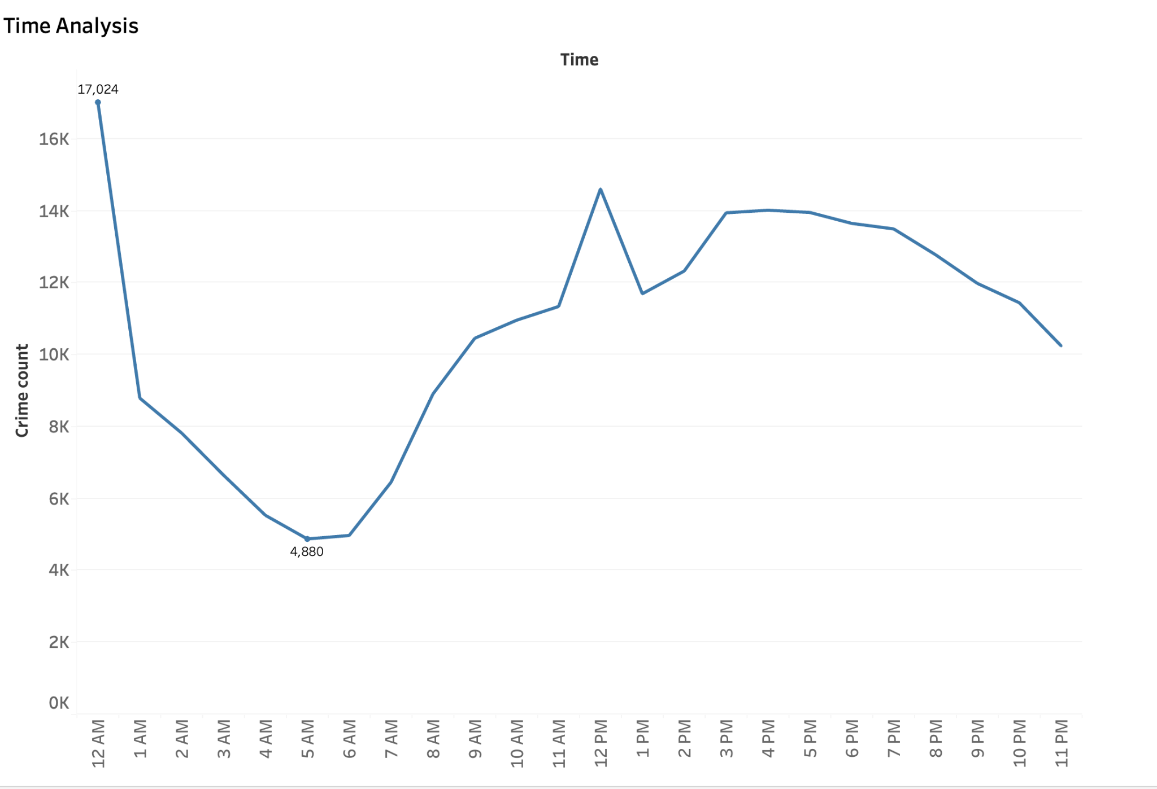
Figure 7. Time Analysis of Crime Rates

Figure 8 provides some additional insights on the day and week crime trends:
- Consistent Patterns Across Days: Midnight (12 AM) consistently shows high crime rates across all days.
- Elevated Weekday Crime: Crime counts tend to rise slightly during weekdays (Monday to Friday), potentially linked to regular commuting and urban activity levels.

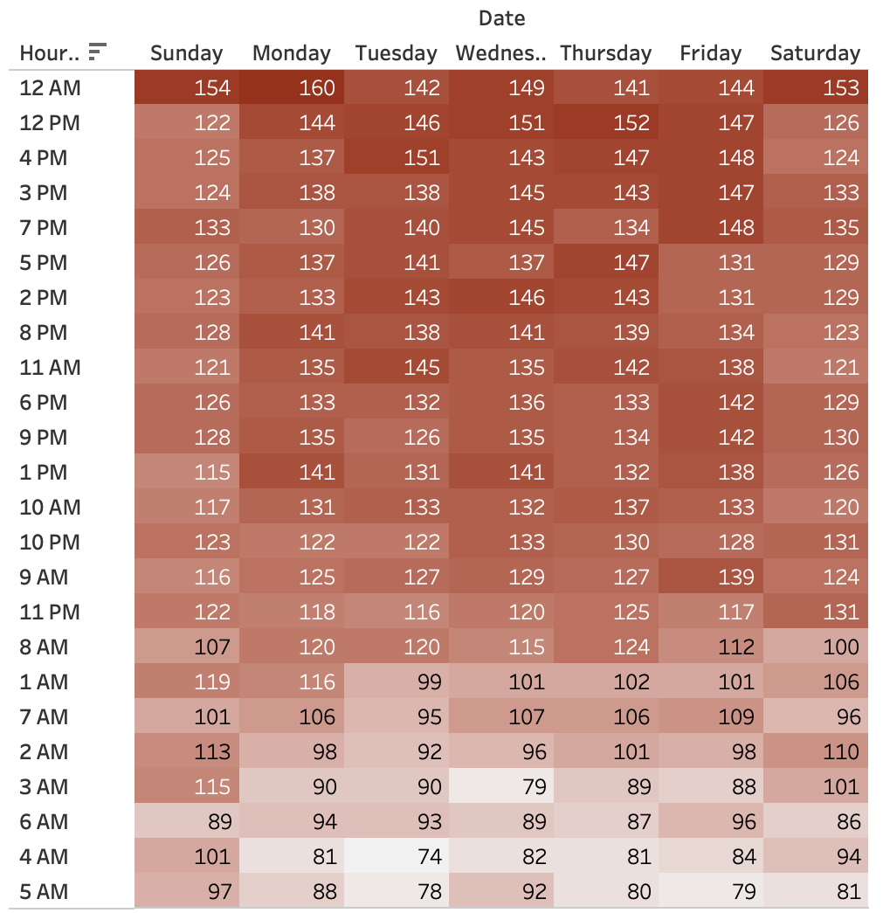
Figure 8. Time of Day and Day of Week Analysis of Crime Rates

A broader analysis of crime over time reveals additional seasonal patterns (Figure 9):
- Winter Dip: There is a noticeable decline in crime during late winter months, likely due to reduced outdoor activities during colder weather.
- Spring and Summer Stability: Crime rates stabilize during spring and summer, likely due to increased public activity and outdoor events.

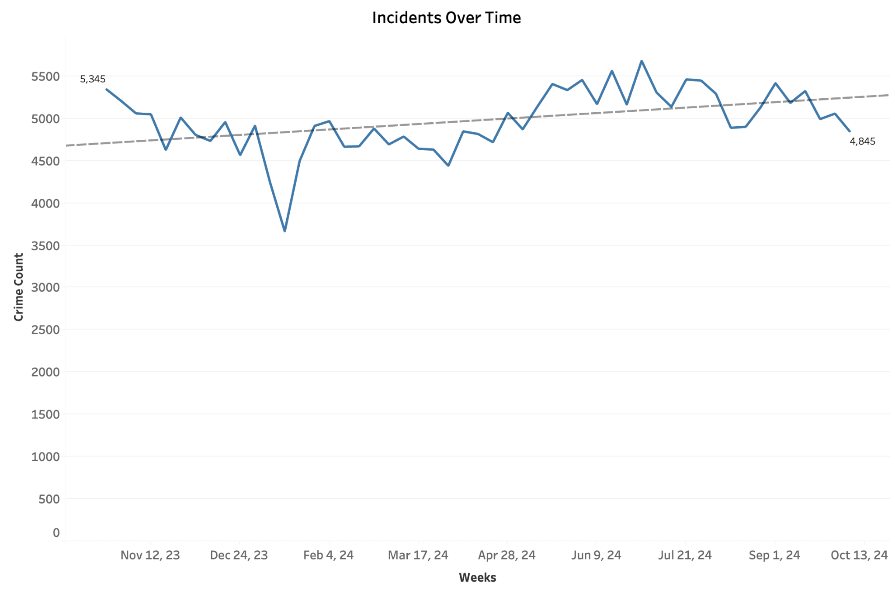
Figure 9. Field and Density Maps for Crime Over Time

7.1.3 Crime Correlations
Figure 10 presents correlations between crime counts and spatial area. This could offer insights into neighborhood safety and potential tourism development opportunities.

Key observations include:
- Low-Crime, High-Opportunity Areas: Neighborhoods like O’Hare and South Deering are spacious and low-crime, which could make them ideal candidates for large-scale tourism development.
- Safe, Lesser-Known Neighborhoods: Areas such as Hegewisch, Ashburn, and Beverly show low crime rates and appeal as quieter, family-friendly destinations.
- High-Crime Tourist Zones: Neighborhoods like Near North Side and The Loop report high crime counts despite being major tourist hubs. This finding suggests the need for strengthened security measures in these areas to safeguard visitors and improve Chicago’s reputation as a safe destination.

By leveraging insights from this analysis, city planners and tourism boards can make informed decisions to diversify tourism offerings, expand into safer neighborhoods, and improve the safety and appeal of high-traffic tourist zones.

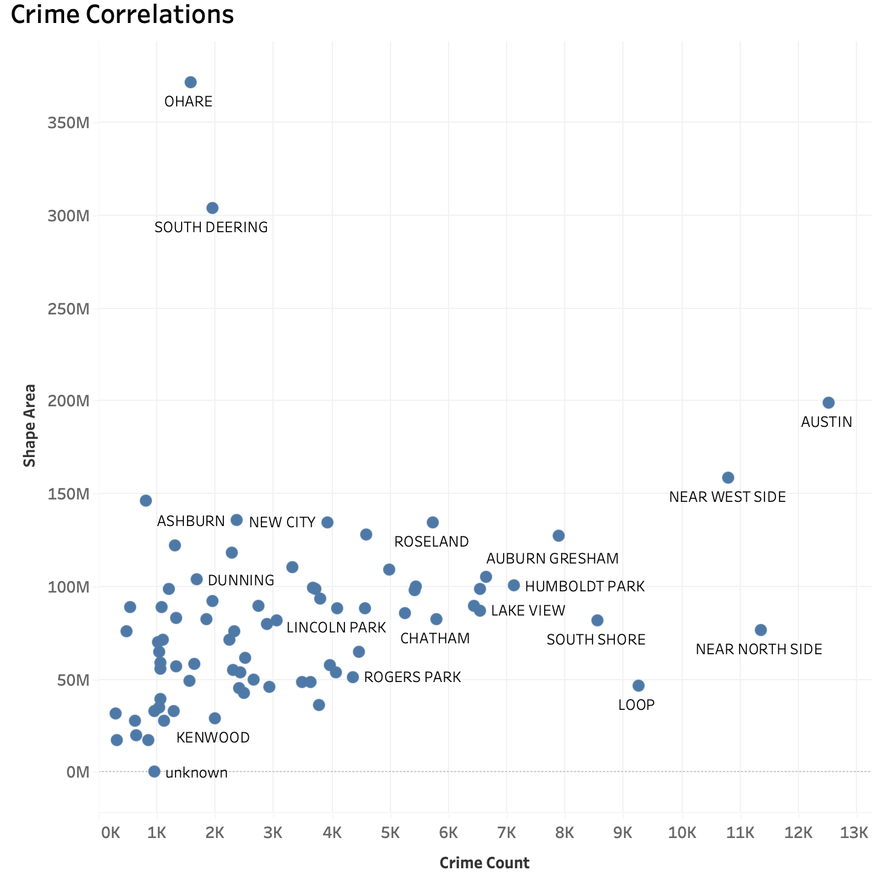
Figure 10. Crime Correlations

7.1.4 Geographical Analysis
Figure 12 illustrates both a density map and a spatial breakdown of crime occurrences by neighborhood.

Key observations include:
- High-Density Crime Areas:
  - The density map reveals concentrated crime clusters in neighborhoods such as Near North Side, The Loop, and parts of the South Side. These areas correspond to high-activity zones with significant population and tourist presence.
  - Commercial hubs, transportation nodes, and entertainment districts have denser crime incidents, which indicates potential risks for visitors and locals in these zones.
- Low-Density Crime Areas:
  - Suburban neighborhoods such as Edison Park, Forest Glen, and Mount Greenwood show minimal crime activity. These areas can be promoted as safe and peaceful options for living and tourism.
- Crime Type Distribution:
  - Crime density patterns differ based on categories (violent vs. non-violent). For example, violent crimes are more prevalent in urban core areas, while non-violent crimes such as thefts and property damage are more widespread across neighborhoods.

By combining density mapping with neighborhood-level insights, stakeholders can address safety concerns while maximizing the city’s potential as a destination for residents and tourists alike.
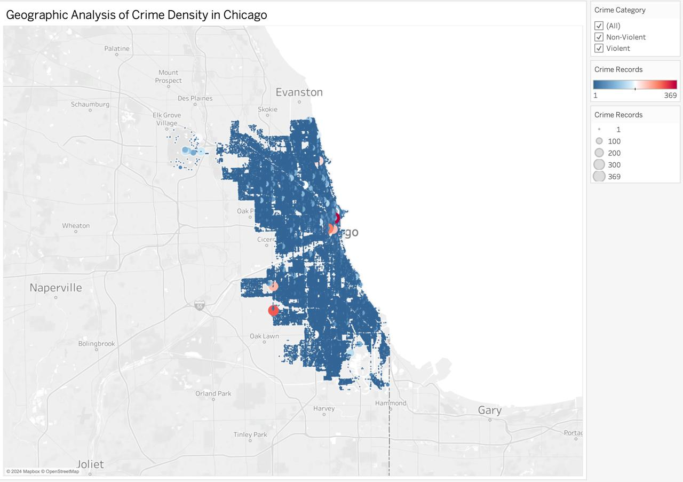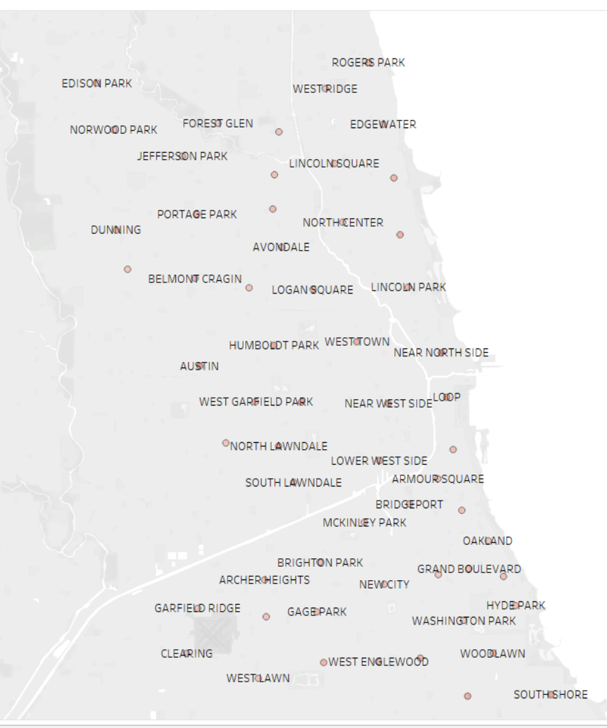
Figure 12. Field and Density Maps of Crime Rates

7.1.5 Crime Types
Figure 13 illustrates the distribution of primary crime types occurring in Chicago. This analysis provides critical insights into the nature of criminal activity and informs targeted strategies to improve safety and tourism experiences.

Key insights include:
- Theft as the Most Common Crime: Theft, with over 59,000 reported incidents, is the most prevalent crime in Chicago. Tourism companies could try visitor awareness campaigns focusing on securing personal belongings, especially in busy tourist areas.
- Battery and Assault: With nearly 45,000 reported cases, battery and assault also remain significant safety concerns. These findings suggest the importance of visible law enforcement or community safety initiatives to reassure visitors.
- Motor Vehicle Theft: Motor vehicle theft has over 23,000 reported cases. Securing parking facilities and educating visitors on vehicle protection (e.g., locking doors, avoiding valuables in cars) can be encouraged to mitigate this problem.
- Relatively Lower Rates of Burglary and Weapons Violations: Crimes such as burglary and weapons violations are reported at much lower rates compared to theft and battery. This could provide an opportunity to market Chicago as safer than its public perception, particularly in areas where these crimes are infrequent.
- Deceptive Practices and Tourist Awareness: While less prevalent, crimes involving deceptive practices (e.g., scams) require focused educational efforts to inform tourists about avoiding potential scams in high-traffic areas. Visitor guides, online resources, and hotel notices can serve as practical tools for this purpose.

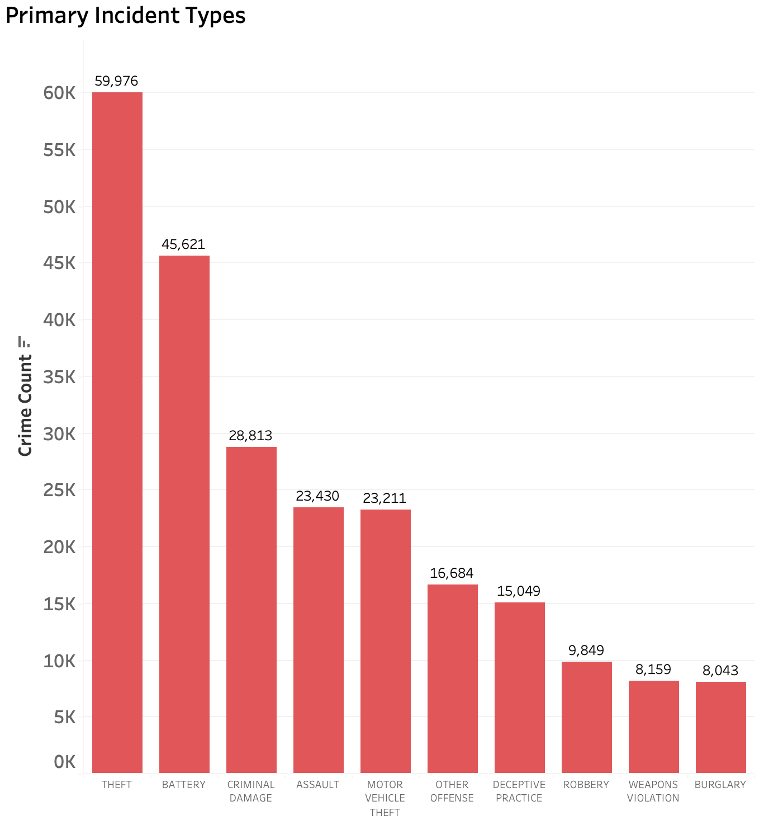
Figure 13. Primary Crime Types

7.2 Tableau Dashboard
Figure 14 to 17 are the interactive dashboards created using Tableau to effectively communicate our findings to stakeholders. These include crime density analysis, time analysis, tourist vs. non-tourist areas analysis, and crime types analysis. Each dashboard includes appropriate filters, such as non-violent and violent crime filters.

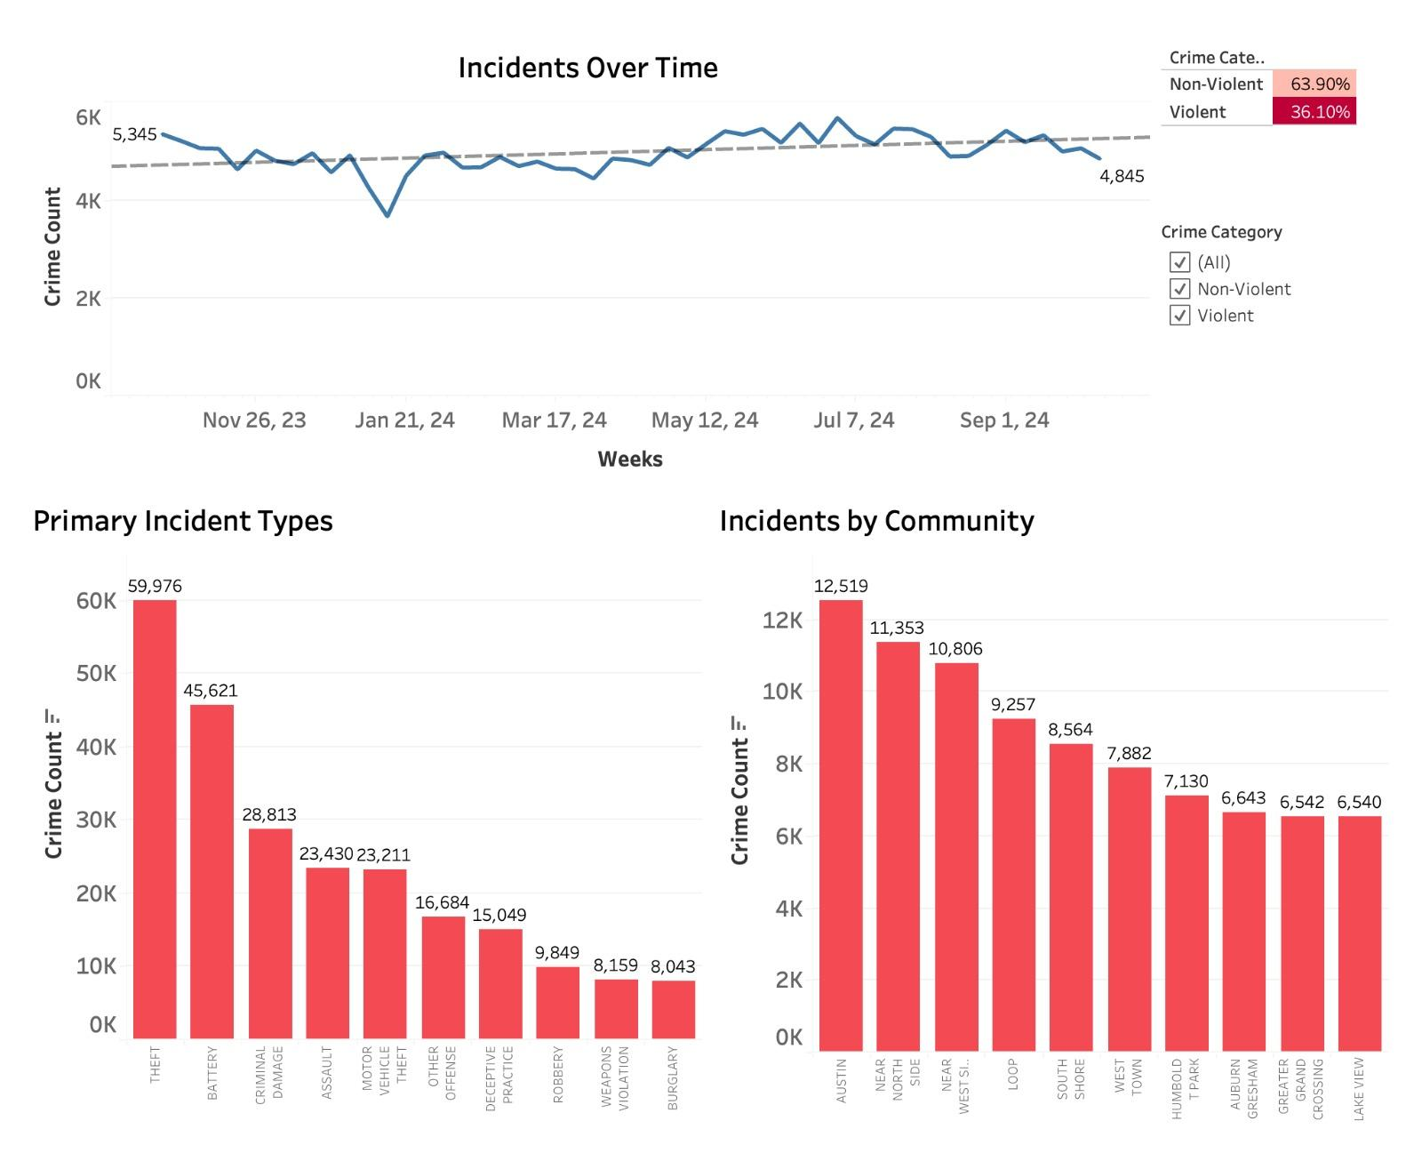
Figure 14. Crime Density Analysis Dashboard
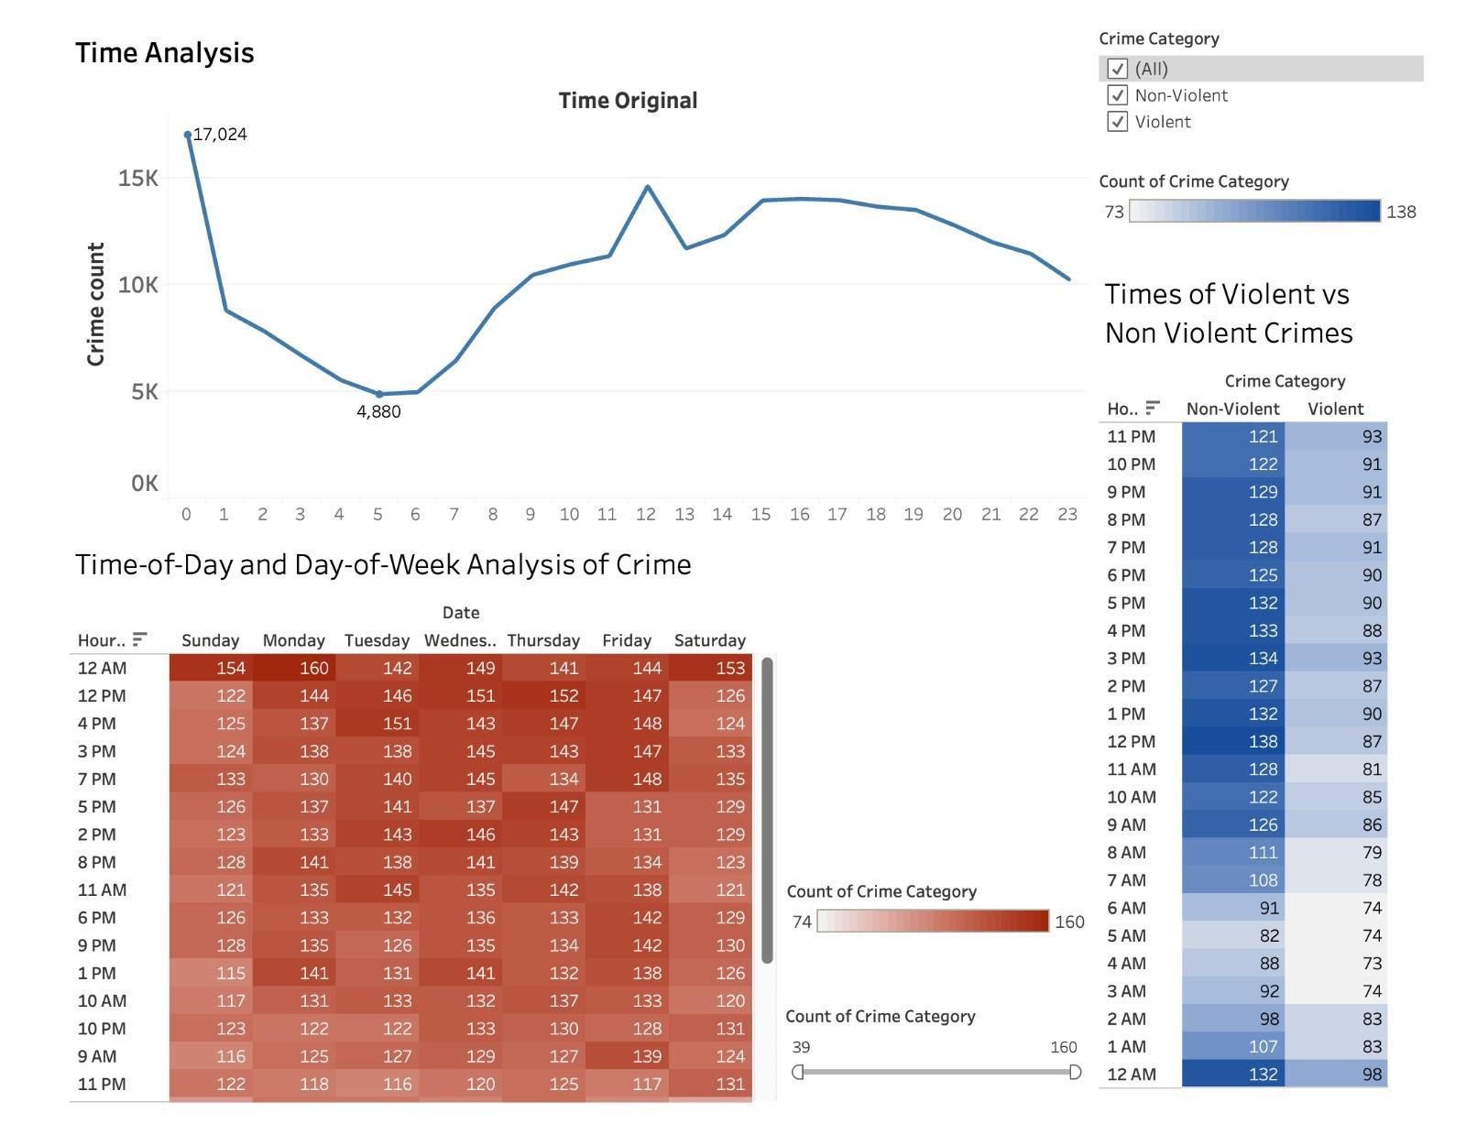
Figure 15. Time Analysis Dashboard
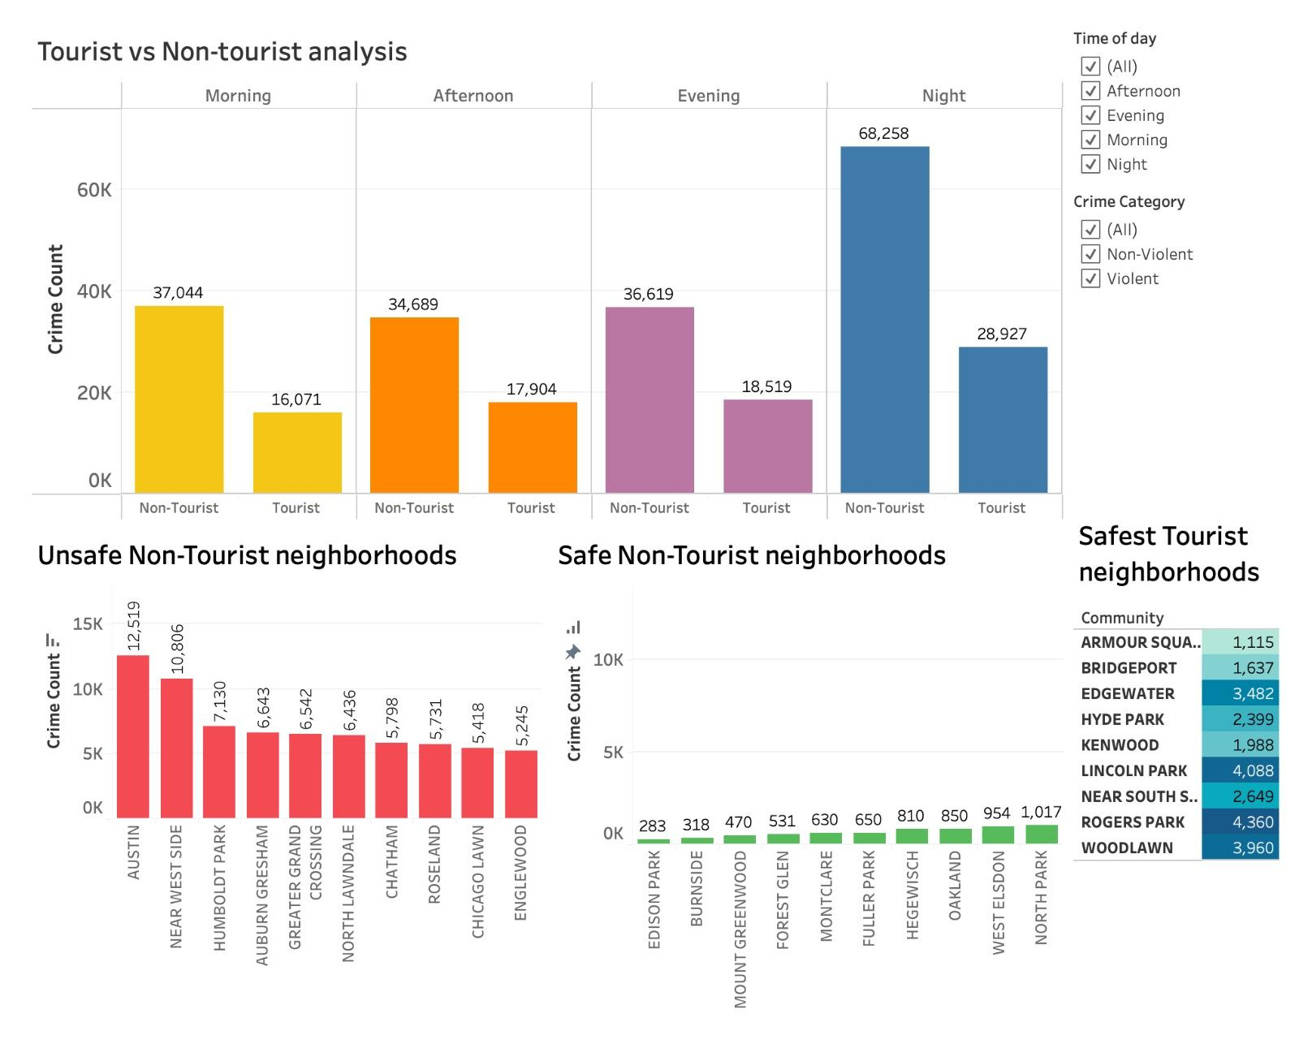
Figure 16. Tourist vs Non-Tourist Areas Analysis Dashboard

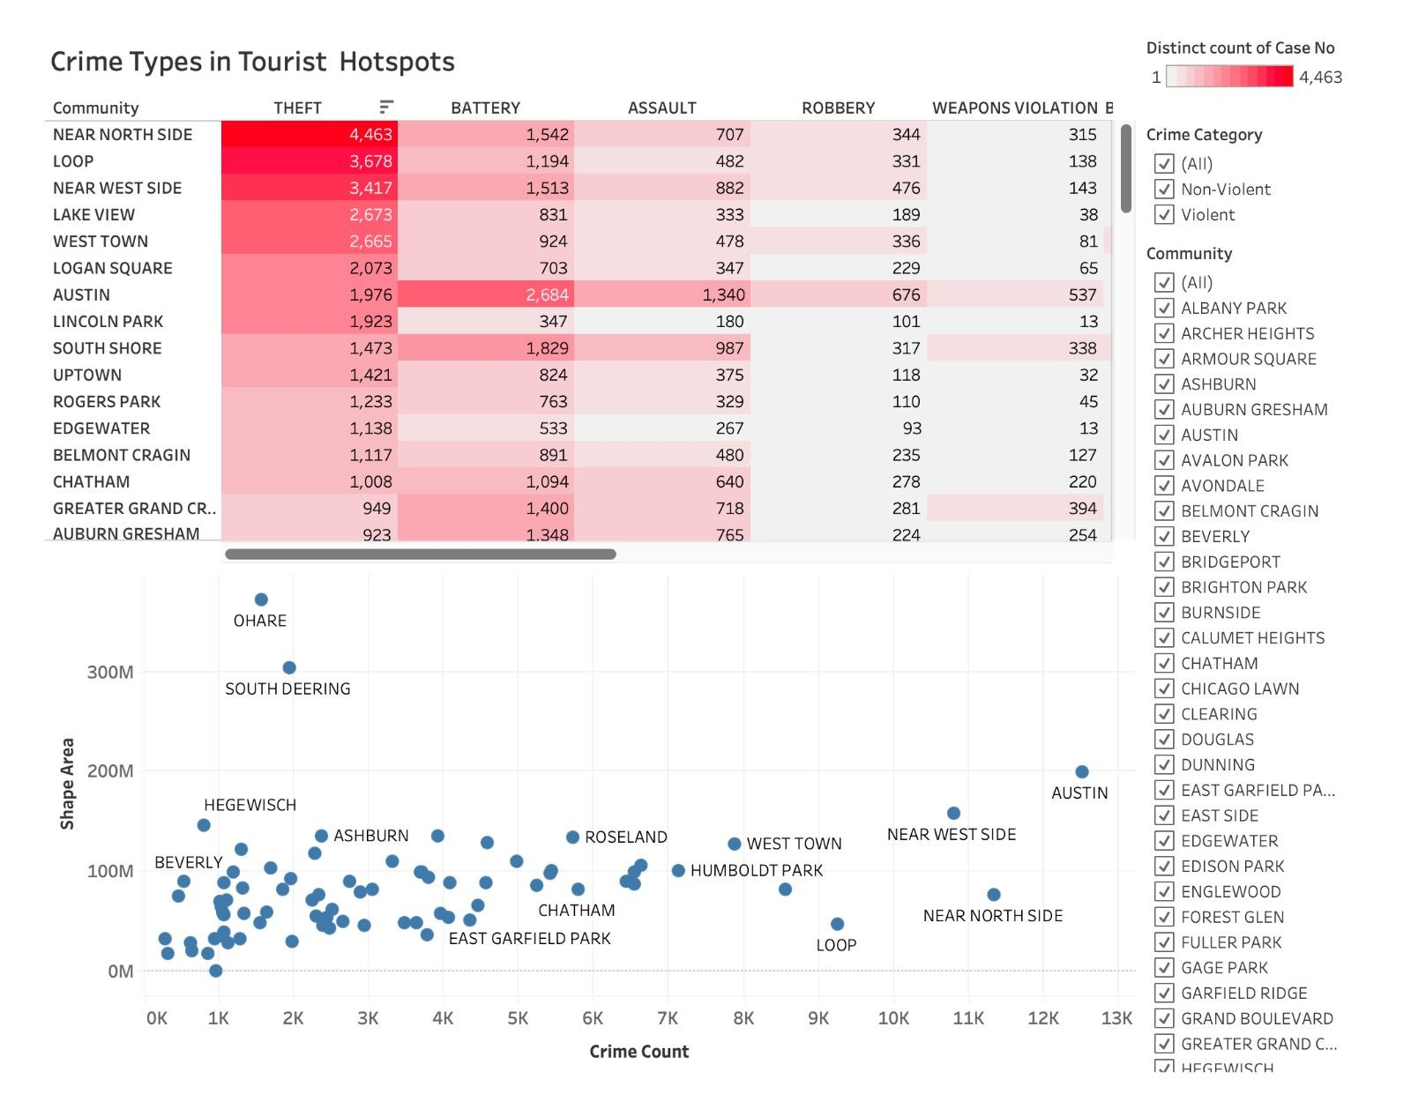
Figure 17. Crime Types Analysis Dashboard

7.3 Business Insights

7.3.1 Recommendations to Enhance Safety & Appeal for Tourism Companies
- Promote Safer Zones: Highlight O’Hare, South Deering, and safe, lesser-known areas like Hegewisch, Ashburn, and Beverly as low-crime, family-friendly destinations. Encourage daytime exploration in tourist areas for added safety.
- Leverage Seasonal and Crime Trends: Market Chicago as a safer city during late winter when crime dips, and during morning and afternoon hours, which report lower incidents in tourist areas. Highlight stable safety levels in spring and summer for sustained tourism promotion.
- Launch Visitor Awareness Campaigns: Educate tourists on securing belongings to prevent theft (the most common crime) and avoiding deceptive practices in high-traffic zones. Promote best practices for vehicle security to reduce motor vehicle theft risks.

7.3.2 Advanced Measures for a Secure Tourism Experience
- Strengthen Security in High-Risk Areas and Times: Increase visible law enforcement and security measures in The Loop and Near North Side, particularly during high-risk times like late evenings (8 PM–12 AM) and midnight, as well as on weekends (Saturday, Sunday, Monday).
- Enhance Safety Infrastructure Around Nightlife and Events: Focus on security measures during nightlife hours (8 PM–12 AM) and late weekends to reduce risks associated with elevated crime during these periods, particularly in nightlife hubs.

8 Conclusion

The Chicago Crime Incident Data Analysis for Tourism Support project has provided valuable insights to address safety concerns and enhance tourism in Chicago. By leveraging detailed crime data, the analysis identified safer neighborhoods, highlighted high-risk times, and explored the nature of crimes affecting tourist and non-tourist areas. This approach not only dispels misconceptions about Chicago’s safety but also empowers stakeholders to make informed, data-driven decisions.

Key lessons learned include the critical importance of data quality in ensuring reliable analysis. Normalization of time, date, and location data significantly improved the depth and accuracy of temporal and geospatial insights. Differentiating trends between tourist and non-tourist areas revealed actionable patterns, enabling tailored strategies to promote safety and attract visitors. Furthermore, visualizations such as dashboards and geographic maps were instrumental in communicating complex patterns effectively, ensuring accessibility for diverse stakeholders.

The insights generated through this project provide actionable recommendations for tourism boards, city planners, and law enforcement. These include promoting safe neighborhoods, enhancing security in high-crime zones, and implementing targeted visitor awareness campaigns. Together, these measures will contribute to Chicago’s image as a safe and welcoming destination, fostering economic growth and sustainable tourism.

